**STANDARD OPERATING PROCEDURE**

**(FOR ADMIN):-**

**STEP 1:-**  Fill your appropriate details required for admin and then click on **Sign** **In** button.

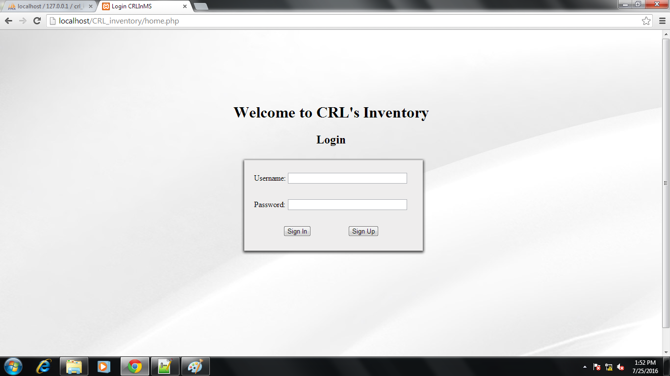

**STEP 2:-** After Singing In you will be forwarded to the Admin Menu page. Here admin can see the details of the Items in the Inventory as shown below:-

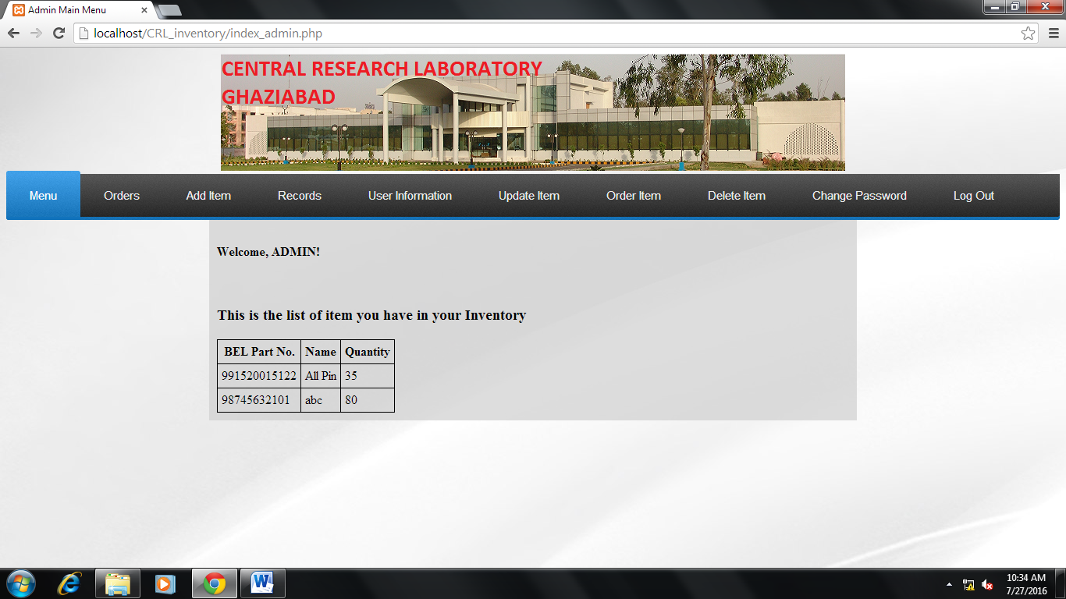

**Step 3:-** To, check the requested items or placed orders click on the Order option.

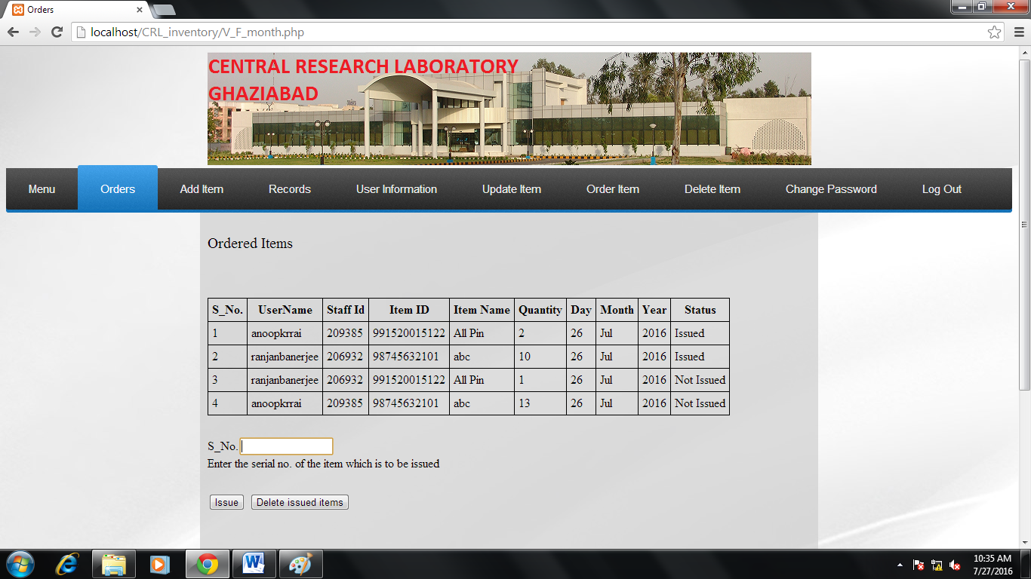

* To Issue an item to the requested person enter the **S_No**. allotted to the person in the field and click on **Issue** button.
* You can delete the issued items from the list by clicking on **Delete** **Issued** **Items** button.

**Step 4:-**  To add an item to the inventory click on the **Add** **Item** option and fill the details of the item and click on **ADD** button.

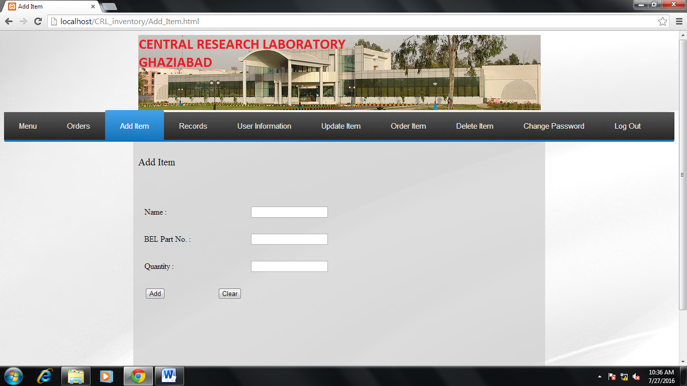

**Step 5:-** To check the Issued Items click on the option **Records**.

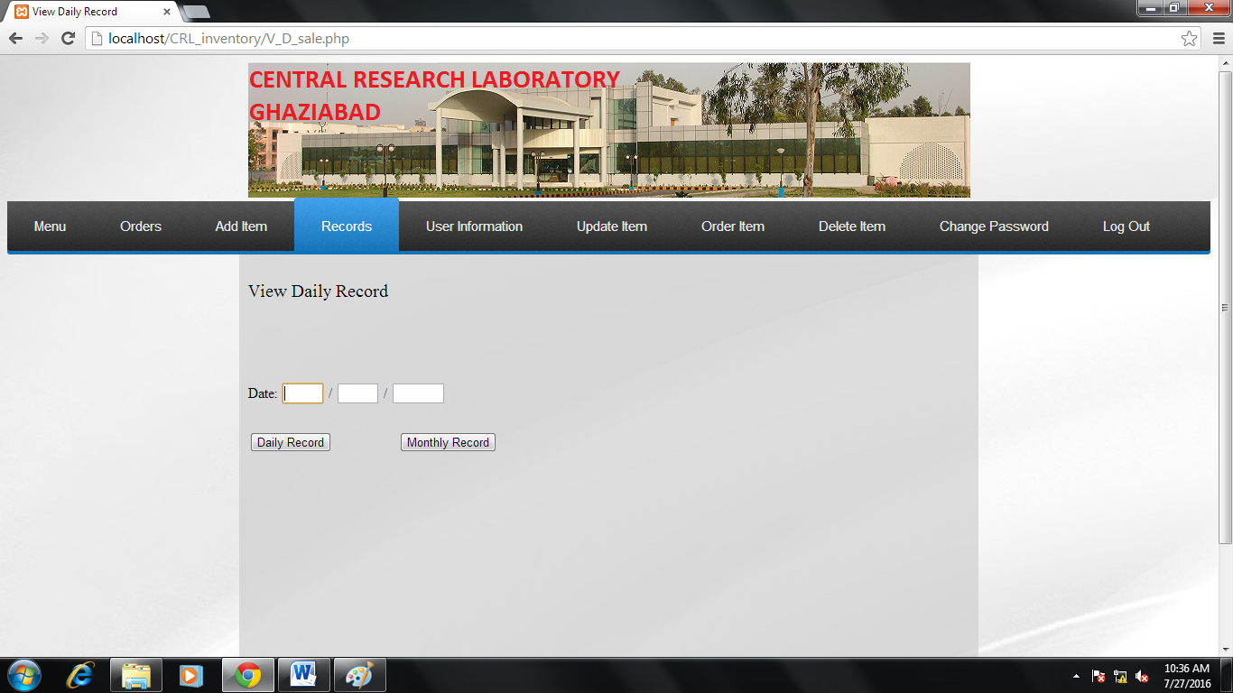

* Fill the date field and check the record of daily issued items as well as monthly issued items by clicking on the **Daily** **Record** button or **Monthly** **Record** button respectively.

**Step 6:-** If you want to see the registered users click on the **User** **Information** option.

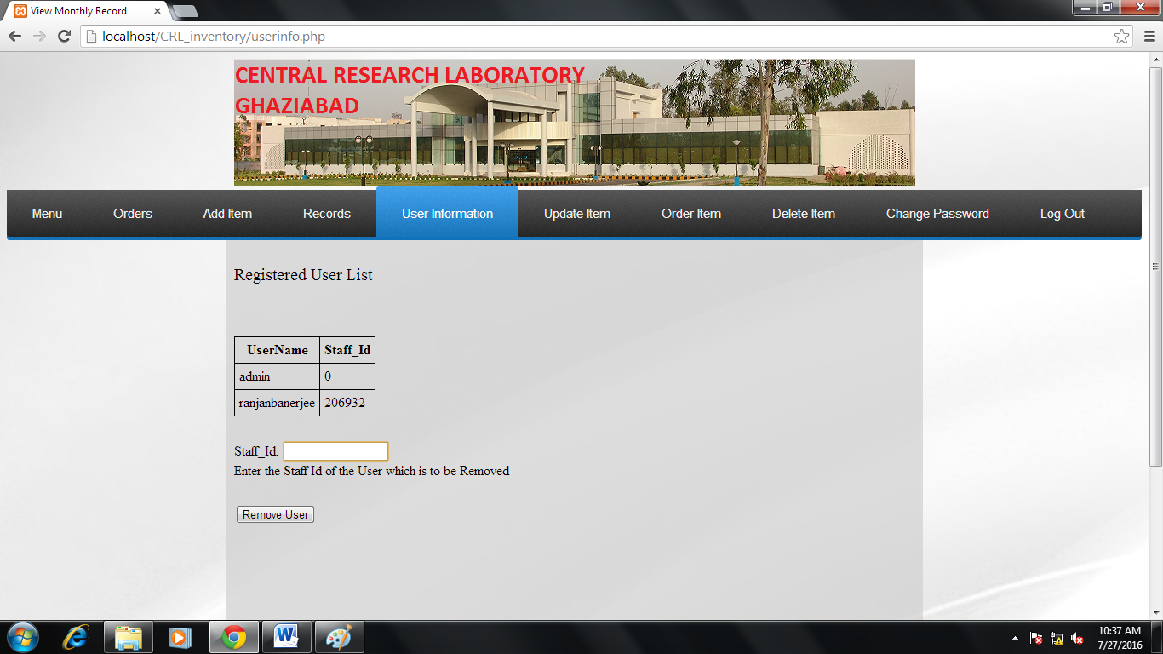

* To remove a user, enter the **Staff**_**Id** of the user and click on the **Remove** user button.

**Step 7:-** To add or remove quantity of an item click on the **Update** **Item** option.

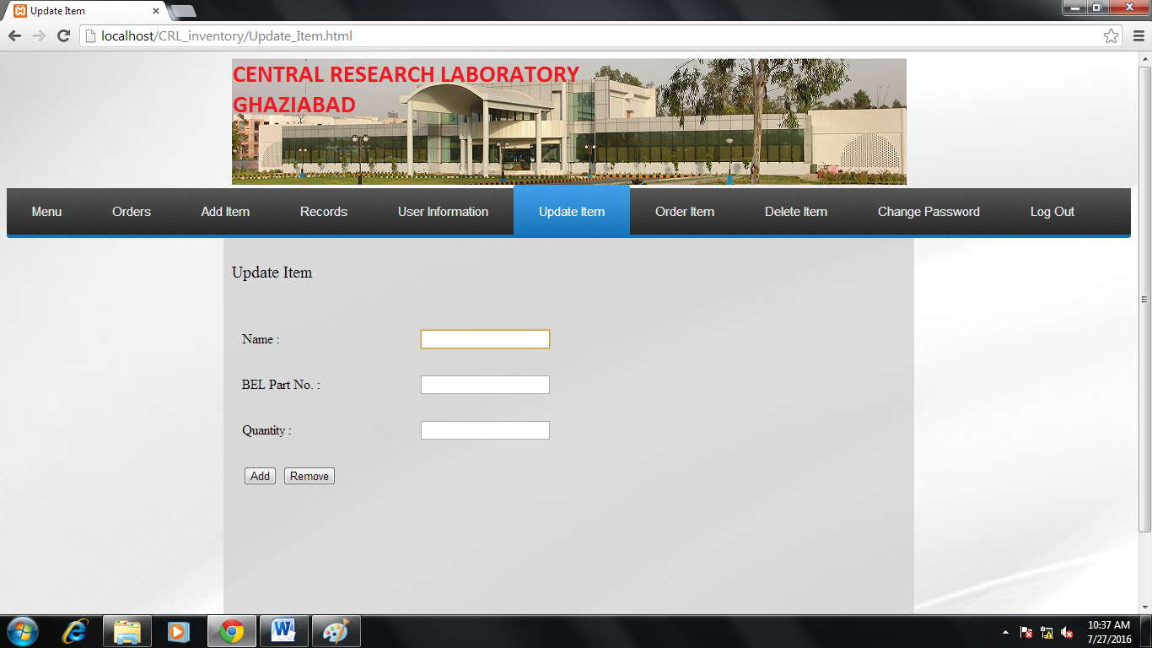

* Fill the detail and quantity to be added or removed from the inventory and then click on **Add** button to add the quantity or to remove quantity click on the **Remove** button.

**Step 8:-** To order an item on the behalf of any user click on the **Order** **Item** button and fill the details asked to you. And then click on the **Issue** button.

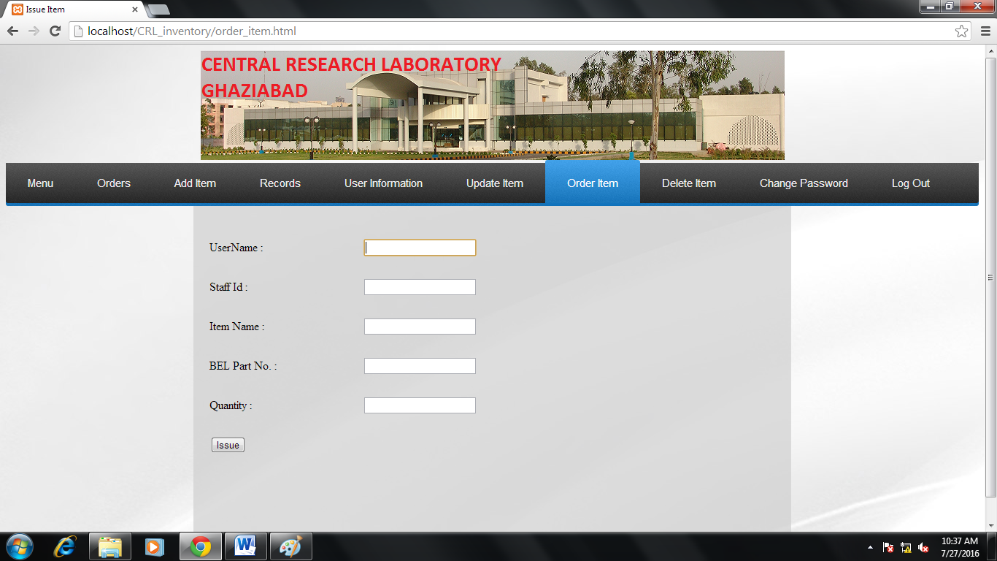

**Step 9:-** To delete an item from the inventory click on the **Delete** **Item** option and fill the **BEL** **PART** **NO**. and click on the **Delete** button.

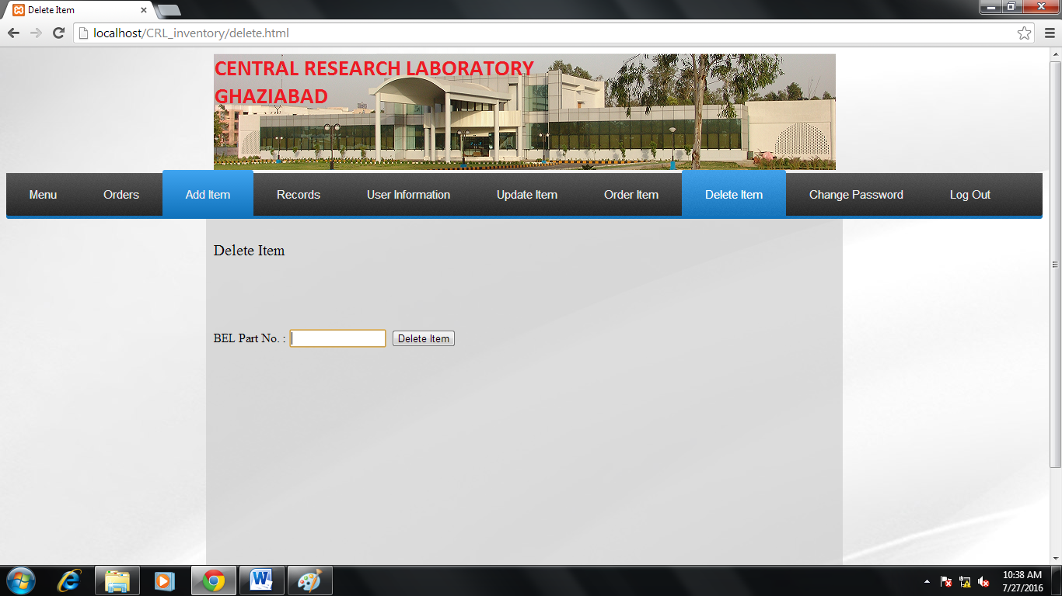

**Step5:-** If you want to change the password of your account then click on **Change** **Password** option.

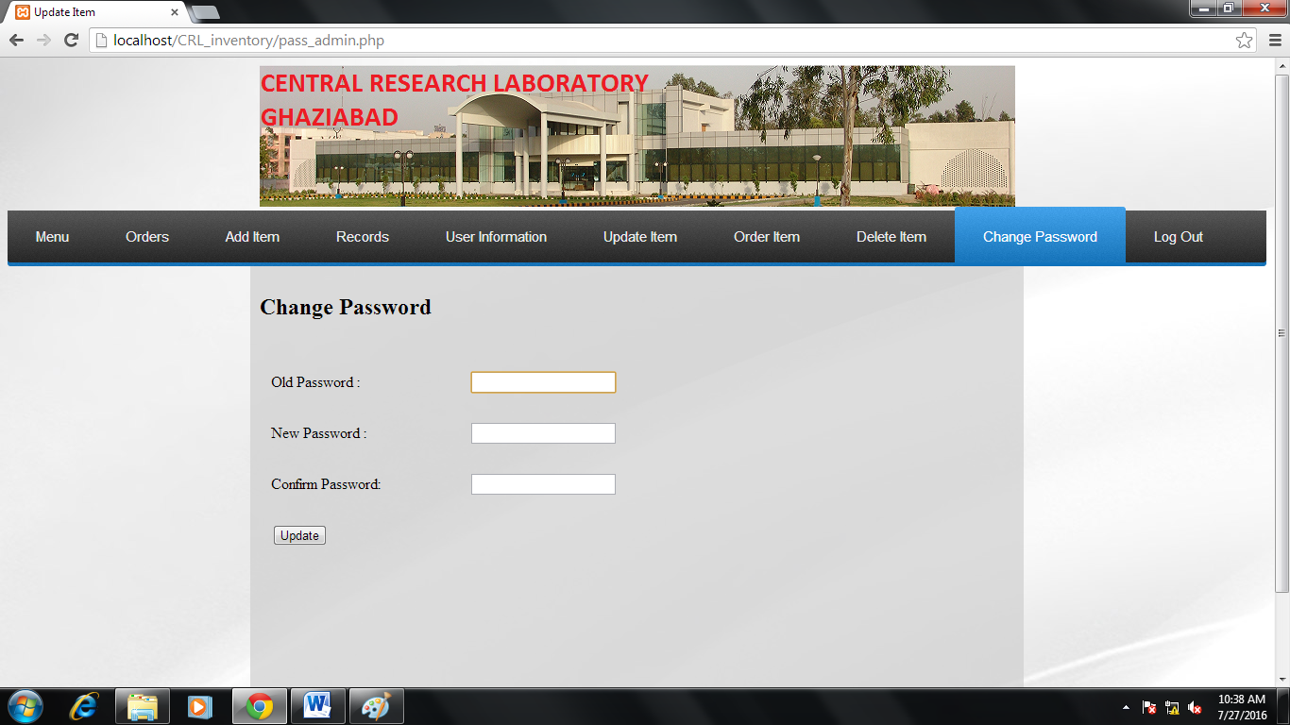

* Fill the Old password then your new password twice and then click on **Update** button and your password is updated successfully.

**Step 11:-** To close your account click on **Log** **Out** option.